Project Design Phase-II
Data Flow Diagram & User Stories

Date | 26 June 2026
Team ID
Project Name | Ucab – Cab Booking System
Maximum Marks | 4 Marks

Data Flow Diagrams:
A Data Flow Diagram (DFD) is a traditional visual representation of the information flows within a system. A neat and clear DFD can depict the right amount of the system requirement graphically. It shows how data enters and leaves the system, what changes the information, and where data is stored.

User Flow Diagram: Data Flow Diagram:
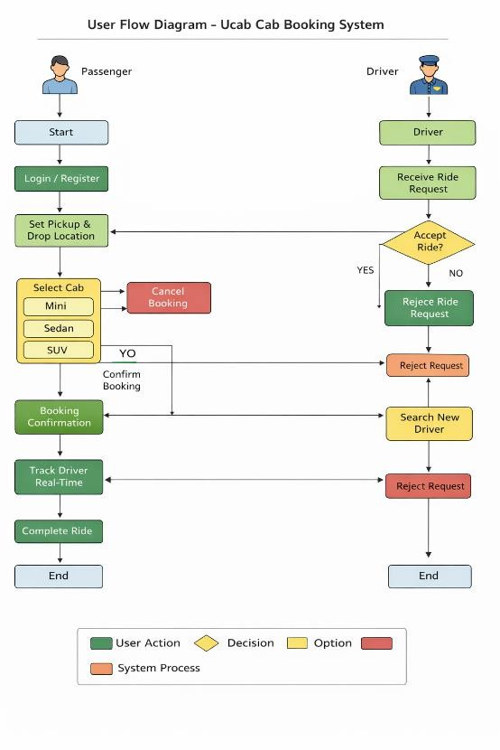
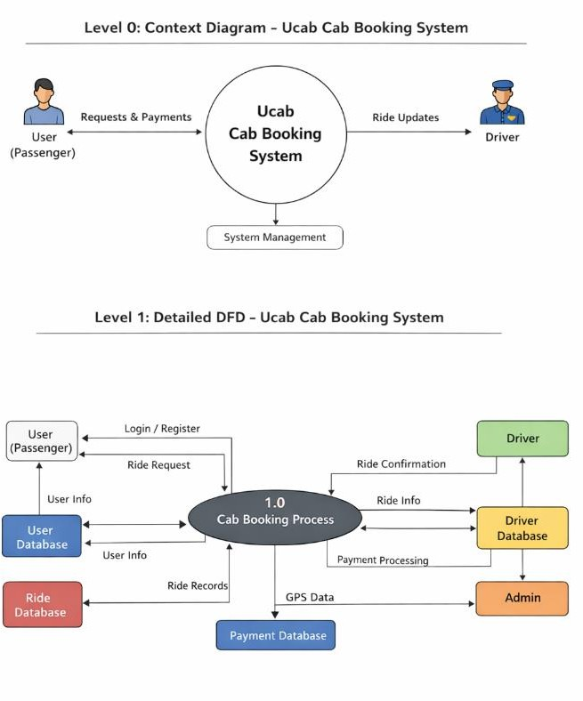

User Stories
Use the below template to list all the user stories for the product.

User Type | Functional Requirement (Epic) | User Story Number | User Story / Task | Acceptance Criteria | Priority | Release
Customer (Mobile/Web User) | Registration | USN-1 | As a user, I can register using email and password. | User account is successfully created. | High | Sprint-1
Customer | Login | USN-2 | As a user, I can log in using my email and password. | User can access the dashboard. | High | Sprint-1
Customer | Cab Booking | USN-3 | As a user, I can enter pickup and drop locations and select an available cab. | System displays available cabs and allows booking. | High | Sprint-1
Customer | Ride Confirmation | USN-4 | As a user, I can confirm my cab booking. | Booking confirmation message is displayed. | High | Sprint-1
Customer | Ride Tracking | USN-5 | As a user, I can track my cab location in real time. | Map shows driver's live location. | High | Sprint-2
Customer | Payment | USN-6 | As a user, I can pay for the ride through online payment methods. | Payment is successfully processed. | High | Sprint-2
Customer | Ride History | USN-7 | As a user, I can view my past ride bookings. | User can see ride details in history. | Medium | Sprint-2
Driver | Driver Registration | USN-8 | As a driver, I can register to provide cab services. | Driver account is created and verified. | High | Sprint-1
Driver | Ride Request | USN-9 | As a driver, I can accept or reject ride requests. | Driver can manage incoming ride requests. | High | Sprint-1
Driver | Ride Status | USN-10 | As a driver, I can update ride status (started/completed). | Ride status updates successfully. | High | Sprint-2
Administrator | System Management | USN-11 | As an admin, I can manage users and drivers. | Admin dashboard shows all records. | Medium | Sprint-3
Administrator | Ride Monitoring | USN-12 | As an admin, I can monitor ride activities. | Admin can view ride details and reports. | Medium | Sprint-3

